**Abhishek Tiwari | Employee Id : 3202759**

* ***Create a virtual network with 2 subnets. Each subnet should have 16 Ips only.***
* ***Inside one of the subnets, create a VM and deploy an application code inside it and it should leverage the database on the cloud (any existing application created by you before)***
* A diagram of a network

  Description automatically generated

# Virtual Machine

# DB

# Running jar File on VM

# Endpoint Point Tested in Browser

* **Deploy the same application to Azure App Service. It should also leverage the database on the cloud.**

Azure App Service Architecture

|  |
| --- |
| Created Jar File |

|  |
| --- |
| Created App Service |
|  |

|  |
| --- |
| Using FTP Server : Securely sharing files using SSL encryption over FTP/FTPS |
| Vnet Intergration to Allow DB Access |
|  |

|  |
| --- |
| Application Running in Browser |
|  |

|  |
| --- |
| Adding New Record Using Postman |

* **Create the AKS cluster (2 nodes, smallest size VM) and deploy any two services on it. Services should be accessible from the internet.**

Aks Architecture

* **A diagram of a computer network

  Description automatically generated**

|  |
| --- |
| Created AKS Cluster |

|  |
| --- |
| Running Aks Cluster |
| List of all deployments across all namespaces in a Kubernetes cluster. |
|  |
|  |

* **Create an Azure function that should trigger as soon as you upload a file in the blob storage. Function should be able to print the name of the file uploaded in the function.**

Azure function Architecture

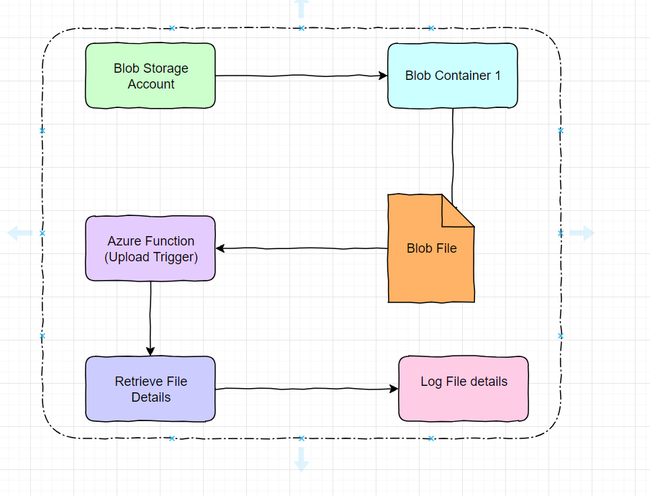

|  |
| --- |
| Blob Trigger Function |
|  |
| Uploaded Files to Container |
| Log Printed on File Upload |
| Function Statisitics of Function trigger on File upload in Constainer |
|  |

## **# Service Used to Completed this assignment.**

**Virtual Network (VNet):** A logically isolated network infrastructure that allows you to securely connect and control resources. It helps organize and isolate resources within your Azure environment.

**Subnet:** A range of IP addresses within a virtual network. It allows you to partition your network into smaller subnetworks, providing organization and isolation for resources.

**Virtual Machine (VM):** A software emulation of a physical computer that runs an operating system and applications. You will create a VM and deploy an application code inside it, leveraging a cloud-based database.

**Database:** An organized collection of structured data stored and accessed electronically. The application code deployed in the VM will leverage a cloud-hosted database for storing and retrieving data. Here MySQL is used as data to private end point, means it can only be accessed in same VNet.

**Azure App Service:** A platform-as-a-service offering for deploying and running web applications and APIs. Here deployed the same application code to Azure App Service, which will also leverage the cloud-based database. Here we also do VNet Integration to access private end point resources such as MySQL Database.

**Azure Kubernetes Service (AKS):** A managed container orchestration service using Kubernetes. Here Created Aks cluster with 1 Node.

**Azure Function:** A serverless compute service for running event-driven code. Azure Function that triggers when a file is uploaded to blob storage, printing the name of the uploaded file.

**Blob Storage:** A service for storing and retrieving large amounts of unstructured data. Azure Functions will monitor the blob storage for file uploads and trigger the function when a file is uploaded.